Grade 6 Mathematics work sheet
1. Find the HCF of 24,28,36
2. Determine if the following numbers are in proportion
i. 75,150,3,18
ii. 21,35,24,40
3. Nirma is 69 years old and purnima is 21 years old. Find the following ratios in their lowest form
i) nirma’s age : purnima’s age ii. purnima’s age : difference of their ages.
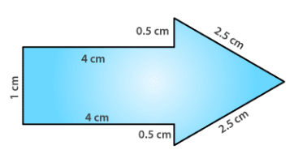
4. Find the perimeter

5. Write the following decimals as fractions. Reduce the fraction to the lowest form.
i. 0.009
ii. 25.68
6. Represent the following numbers on a number line.
i. 5 more than 2
ii. 4 less than 7
7. Give expressions in the following cases.
(a) 5 times y from which 3 is subtracted
(b) y is multiplied by -8
(c) y is multiplied by -8 and then 5 is added to the result
(d) y is multiplied by 5 and the result is subtracted from 16.
8. Find the mean proportion of 4 , 36
9. The mass of 5 bags of cement is 250 kg. What is the mass of 90 bags of cement?
10. Pick out the solution from the values given in the bracket next to each equation.
Show that the other values do not satisfy the equation
a) r – 4 = 0 (4, -4, 8, 0)
b) x + 4 = 2 (-2, 0, 2, 4)
11. A room is 14m 50 cm long and 6 m 80 cm wide. Find the cost of carpeting it at the rate of Rs. 61.50 per square meter.
12. Find i)105 – ( -68)
ii) (-46)-(-34)
13. Convert to improper fractions
i. 450/3 ii. 312/9
14. Compare
i. 0.22 , 0.42
ii. 6.456,6.045
15. Write the factor tree for 216
16. Write the following in the place value table.
i. 500.045
ii. 234.68
iii. 0.256
17. Draw concentric circles of radius 4.5 cm and 5.3 cm.
18. Draw a line segment PQ, make a point A on the line. Through A draw a perpendicular to PQ.

